User Instructions

CourseBin

Thomas McKanna

Sierra Madrid

Cole Dieckhaus

Table of Contents

|  |  |
| --- | --- |
| Creating an account .......................................................  Search for Content .........................................................  Download Content .........................................................  Submit Content ..............................................................  Running the Server ........................................................ | 3  4  6  7  8 |

Creating an Account

To create an account on CourseBin open up the application and click the Sign up button in the top right corner.

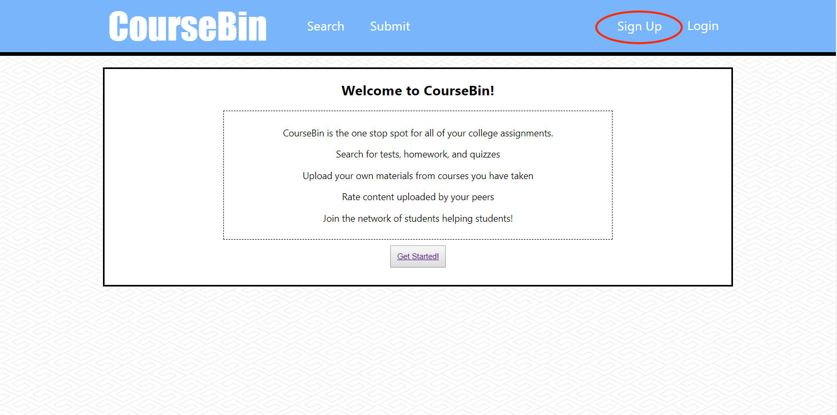

This will open up a new page to make your account. Create a username and password then click the Sign Up button.

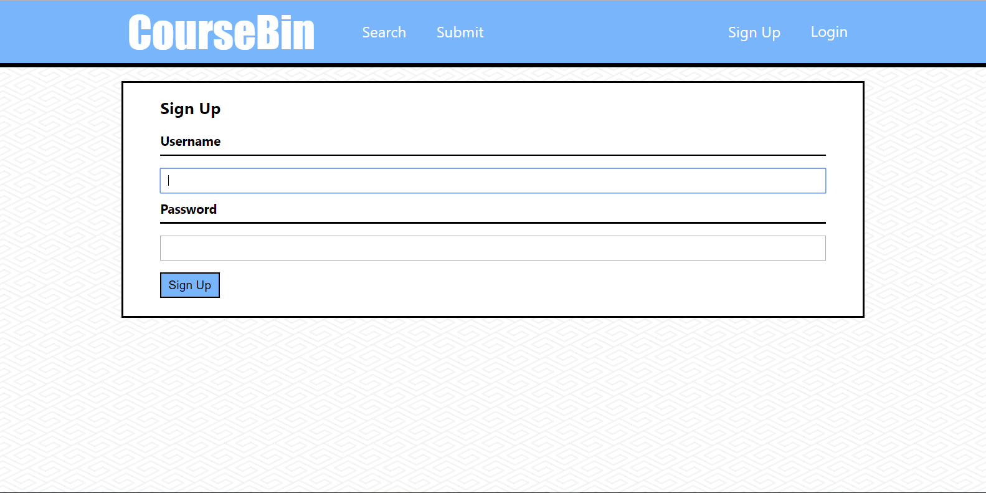

Search for Content

To search for content click the Search button next to the logo in the header or click the Get Started button on the homepage.

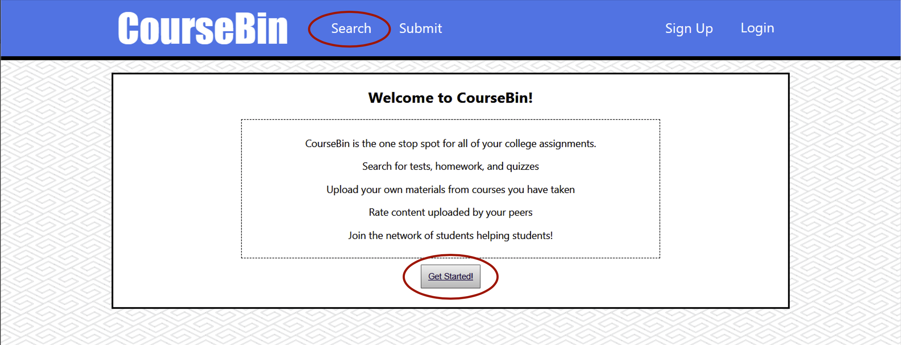

Fill out the required fields.

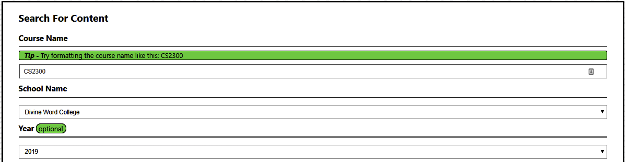

Click Search when you are finished.

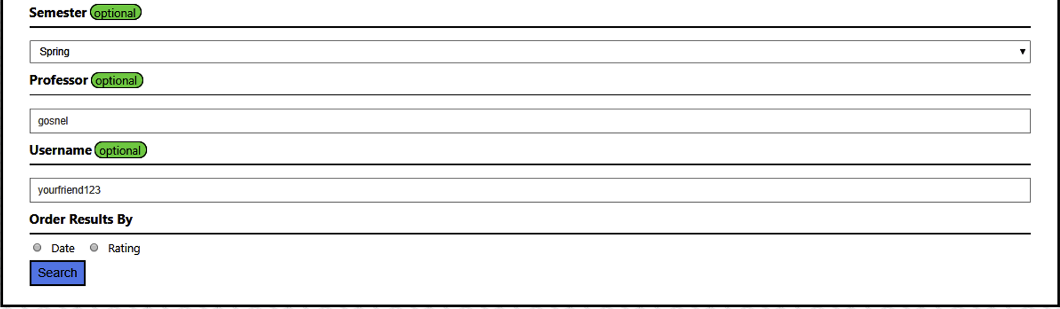

This will take you to another page with all results matching your search criteria sorted in the order you chose. Click the arrow on the top right hand corner of the submission to access the content.

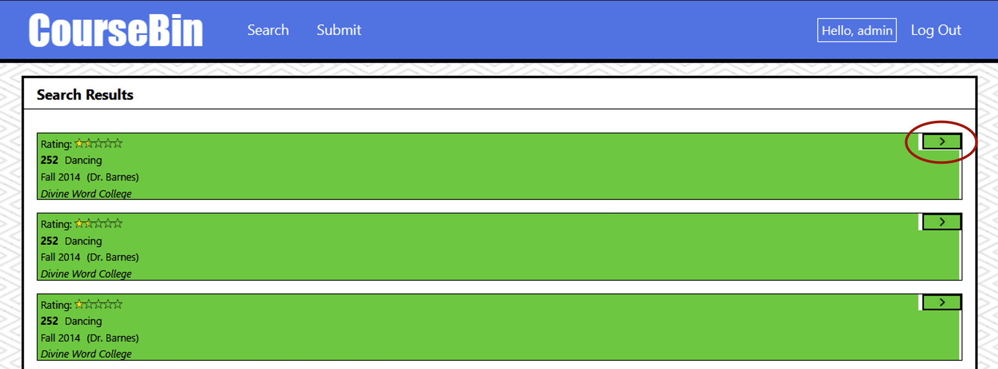

Download Content

When you select a submission on the search page it will navigate to a new page detailing the submission. To download the content or submissions click the download button in the bottom right corner.

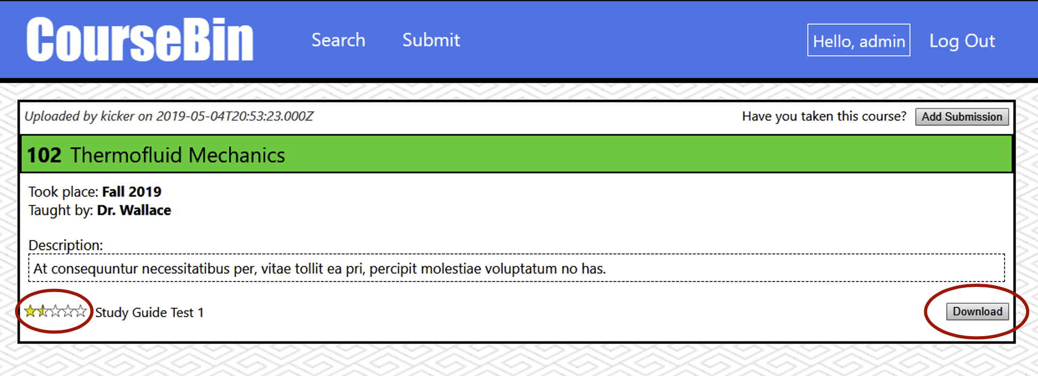

You can also rate the submission based on a five star rating in the bottom left corner if you are signed in.

Submit Content

To submit content, log in and click the submit button at the top of the screen.

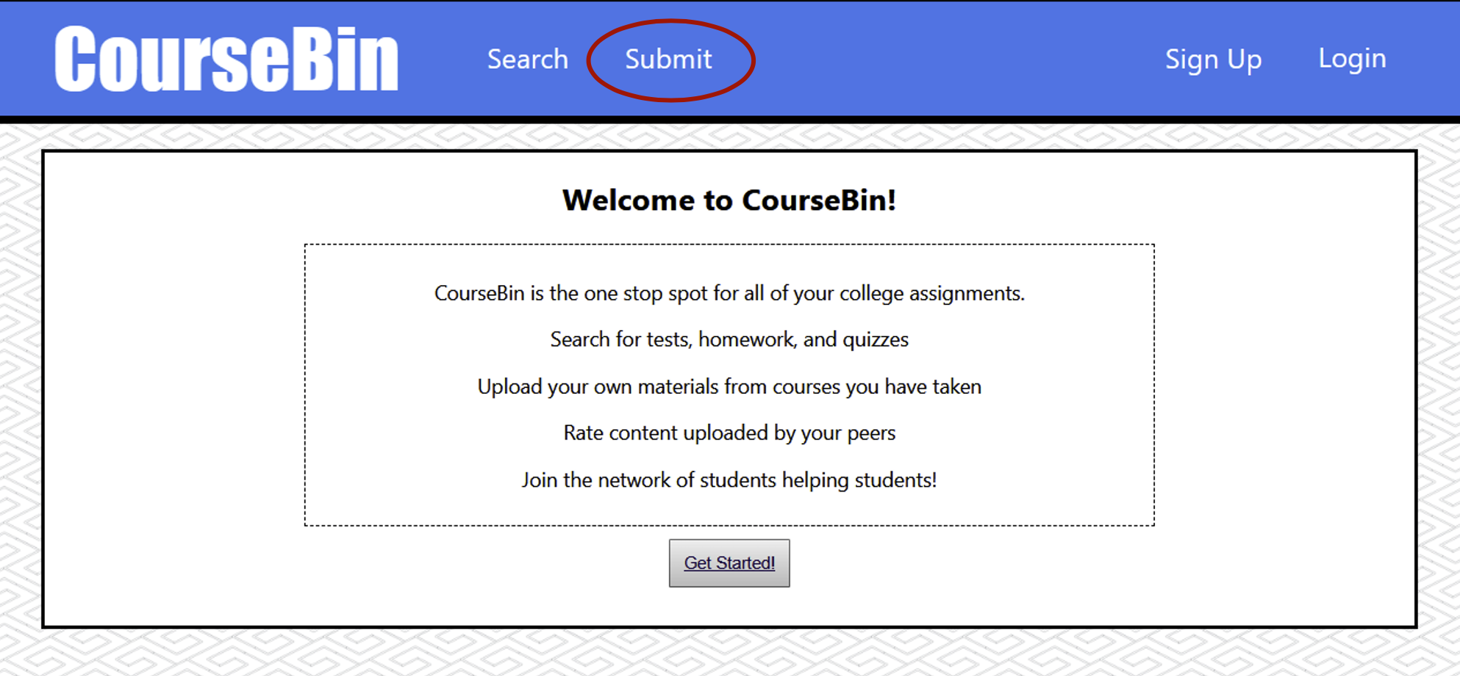

This will bring you to a page similar to the search page (see page 7). Fill out the required material then click submit. From the new Submission Page you can add a description in the Description box and upload your files by clicking the Choose File button. Click Create Submission when you are finished.

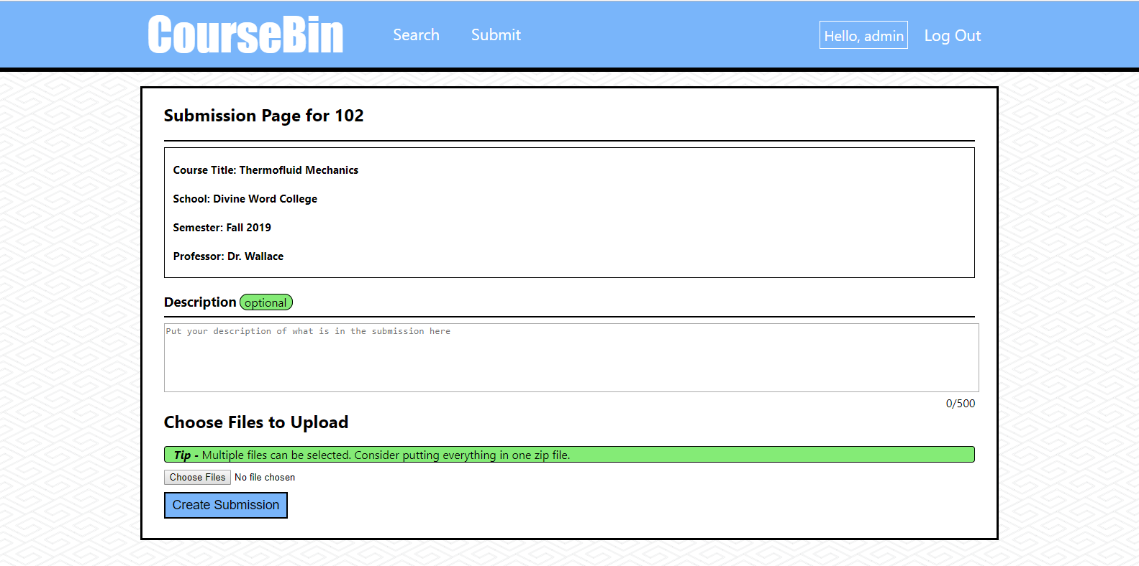

Running the Server

The website requires three servers to be running at the same time: a MySQL server, an Express.js server, and a React.js server. The instructions for obtaining each of these servers can be found on each vendor’s website. To run the website, ensure than the MySQL server is running, and then follow these two instructions:

1. Open a terminal, change to the frontend directory of the CourseBin folder, and then type “npm start”
2. Open another terminal, change to the backend directory of the CourseBin folder, and then type “npm run dev”

These two commands will allow the website to function as intended. Please not that the password to the MySQL server should be “password”.